**Name: Bhupinder**

**ID: 3157552**

**Title: Court Cases**

**Task 1 - Identify the problem**

**Call Discussion with Client: Inderjit**

I am writing the matter call record with Inderjit. He is Lawyer. he wants a software to add the records of his cases and make the records on registers for future. where he is facing so many problems to maintain the record. he always wastes so much time to find the client details from copies and registers and sometimes he lost the records. so he has to face so many difficulties to maintain the record for future. So he needs an application for the record maintence where he can see on which date he has case in court and with which client.

**Task 2 - Define and document requirements**

Requirement of The Software

Scope of Work

*Features: I am going to create software of on Courtcases. Which will be fully automated and Inderjit can maintain and store the data for future. He can see all the cases and hearings through this application online. This application would be fully secure. Data will be saved in the future efficiently. And no unauthorized person can make changes in it. So Application would be very effective and efficiency.*

*Functional Requirements: Demanded requirements by end user:-*

1. *He wants judges modules save update and delete and list of judges to view.*
2. *Then he wants lawyers module in the software.*
3. *He wants court room available his court in the software.*
4. *He wants the record of applicants.*
5. *He wants login and logout facility in the software.*

*Non-functional requirements:*

1. System should be secure.
2. System should be portable.
3. Performance of system should be good.
4. System should be flexible.
5. System should be reliable.

Time: It will take minimum 20 days to complete.

The 4 essential steps of the Risk Management Process are:

1. Identify the risk.
2. Assess the risk.
3. Treat the risk.
4. Monitor and Report on the risk.

Cost: $320

Project Management: here are a few essential questions that are worth to answer during measuring your project success. For a greater understanding of the topic, we will use here the examples connected with the type of projects that we have the greatest knowledge about. And that’s web & mobile app development.

**Task 3 - Design mockups**

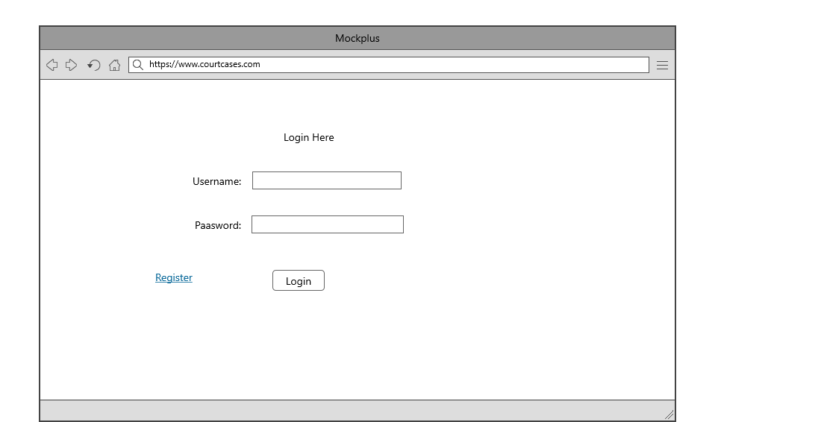

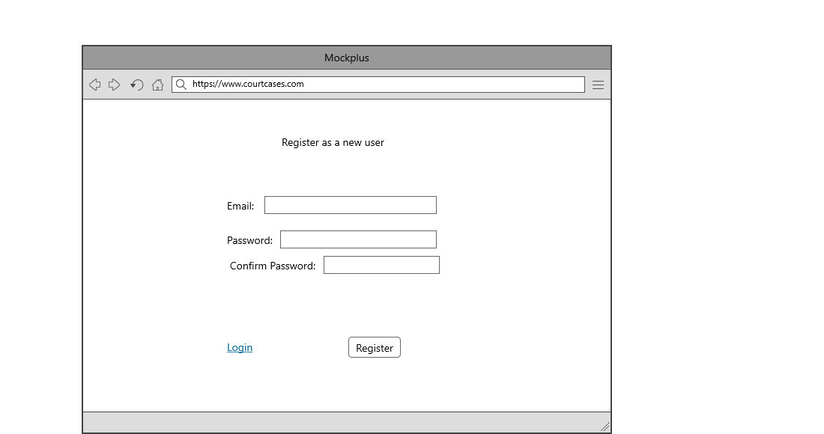

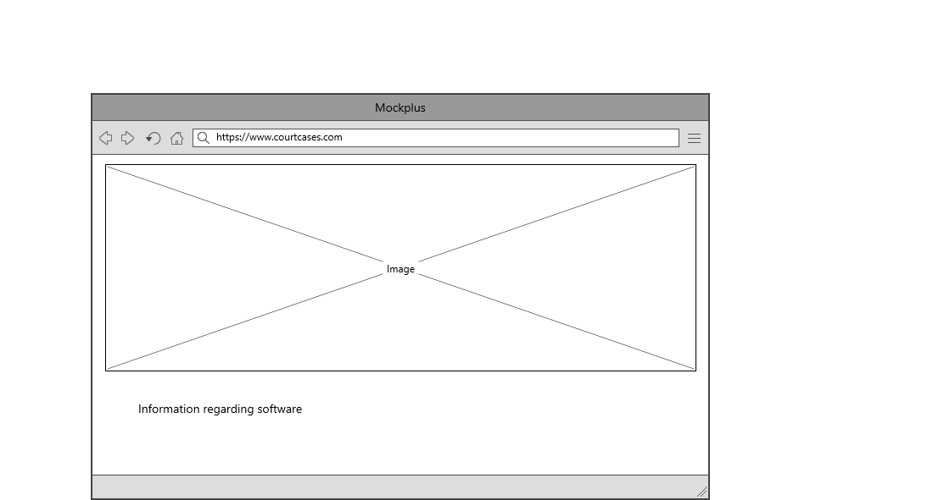

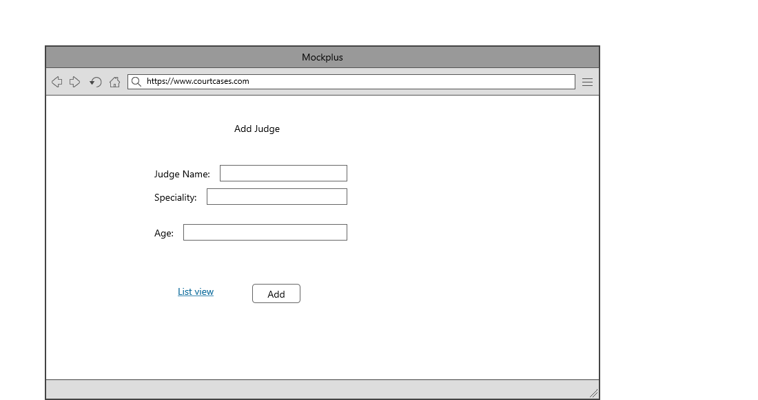

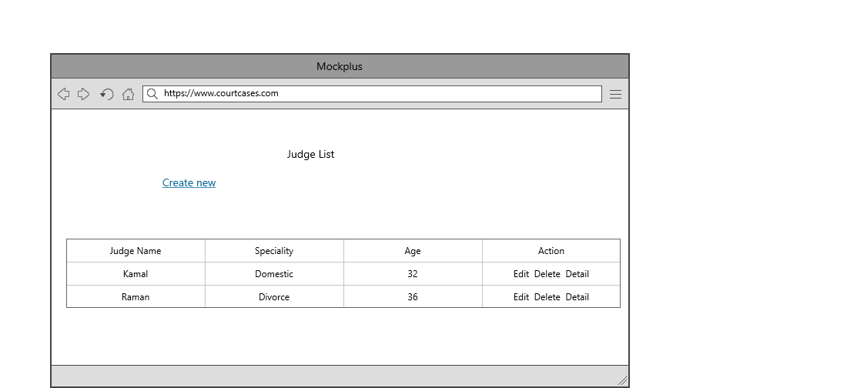

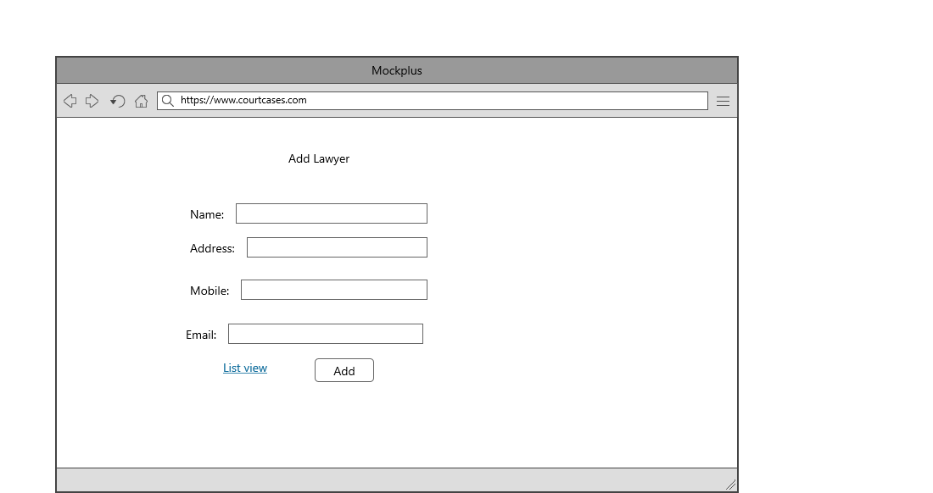

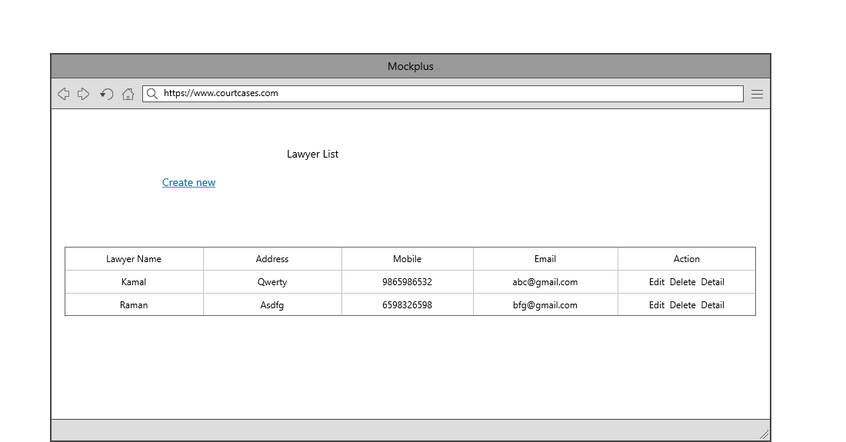

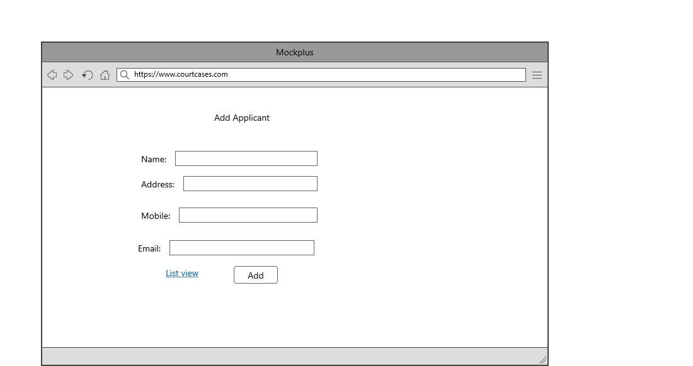

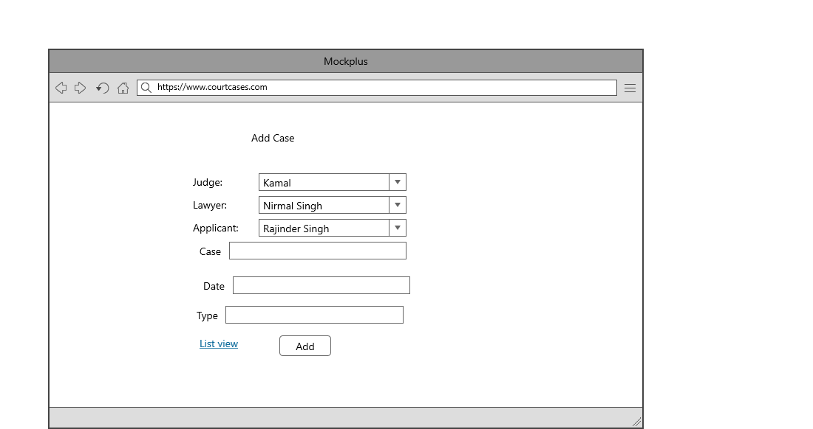

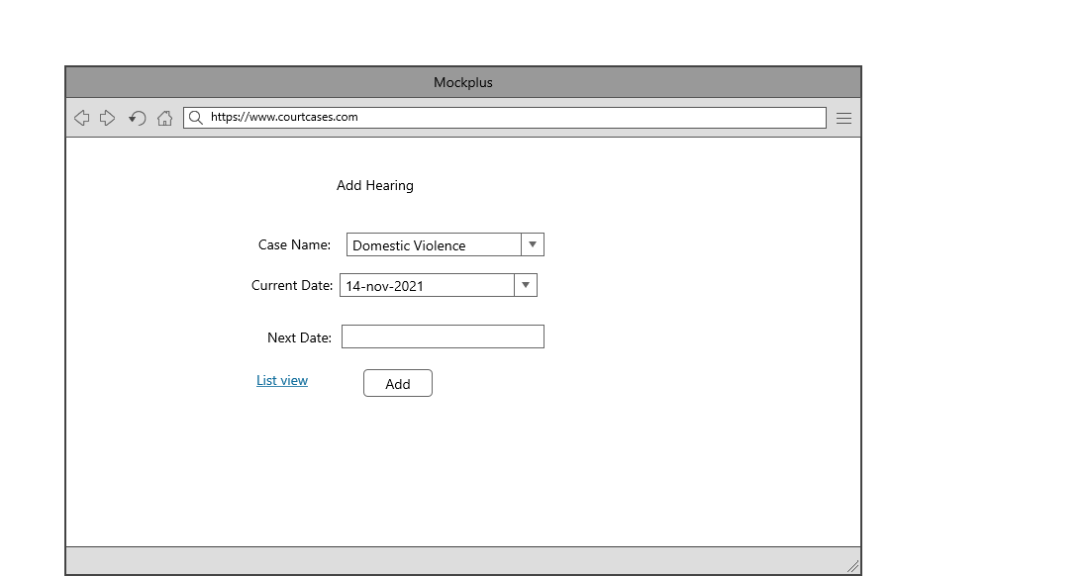

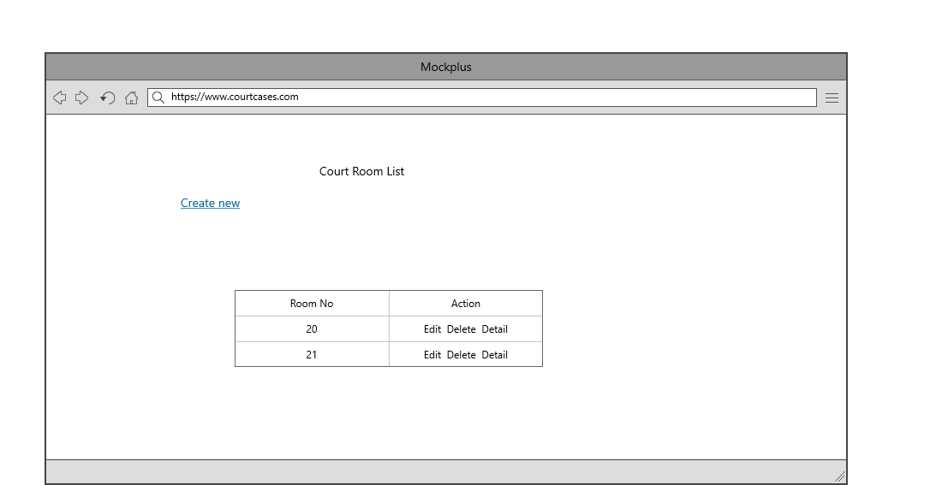

## Task 5- usability testing

|  |  |  |  |  |  |
| --- | --- | --- | --- | --- | --- |
| **User #** | **Login form** | **Register form** | **Hearing Module** | **Pass / Fail / Not executed / Suspended** | **Reviews** |
| Inderjit | completed as expected | Page is good | As Expected perfect | Pass | All modules are ok |
| Ram | should some changes and expand more | good | might be more attractive | Pass | Login form should be more attractive |
| Rajan | looking good | nice | Ok | Pass | all modules are as expected |
| Sham | nice | Ok | Perfect | Pass | nice |

**Task 6 - Meet with your client**

Client Meeting:

|  |
| --- |
| Meeting Details |
| * Date and time: 26-Oct-2021 * Location: Newzealand |
| Attendees: Bhupinder and Inderjit |
| Agenda: Discussion of Software of Court cases system |
| Discussion (Important Points): Written on this document sheet regarding the requirements of the software. |
| My To Dos (Actions): Firstly I have to make the mockups of the application. Then Starting the application after the next meeting. |
| Questions requiring Follow- Up: Discussion of the mock ups |
| Comments: Inderjit is good person and he described regarding software very wisely. |
| Next meeting  Date and Time: 1- Nov-2021 1:00 Pm  Location: Newzealand  Agenda: Showing the mock ups to the client and discussion about further development. |

**Task 7- Presentation**

[**video1528021939.mp4**](video1528021939.mp4)

**Task 8 - Software development life cycle stages**

**Planning :-** The purpose of the Planning Phase is to plan all project processes and activities required to ensure project success and to create a comprehensive set of plans, known as the PMP, to manage the project from this phase until project termination.

**Requirement :-** he Software Development Life Cycle begins with requirement analysis phase, where the stakeholders discuss the requirements of the software that needs to be developed to achieve a goal. The aim of the requirement analysis phase is to capture the detail of each requirement and to make sure everyone understands the scope of the work and how each requirement is going to be fulfilled.

**Software Design and prototyping :-** In this phase, the requirement gathered in the SRS document is used as an input and software architecture that is used for implementing system development is derived.

**Output Screens**

**1. Register Page: -** This is Register page in which You can register new user

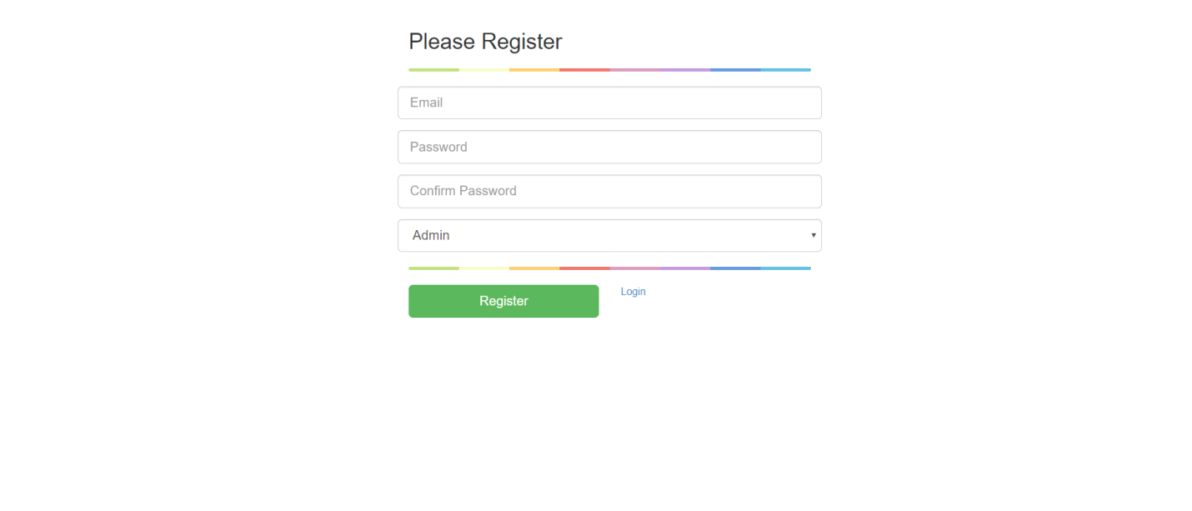

**2. Login Page: -** This is Login page of our website. In this page I can login as a Admin and As a Manager.

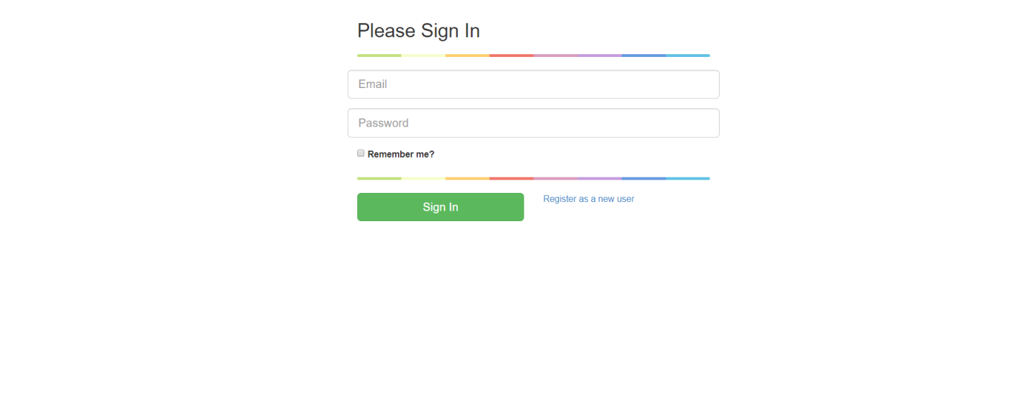

**3. Admin Login**: When admin logins then he can access the all modules of website. Which are shown in the picture.



**4. Judge: -**  Here I can show the judge in my website. And clicking on the create new link I can create the judge. Edit and delete judge are also available here.

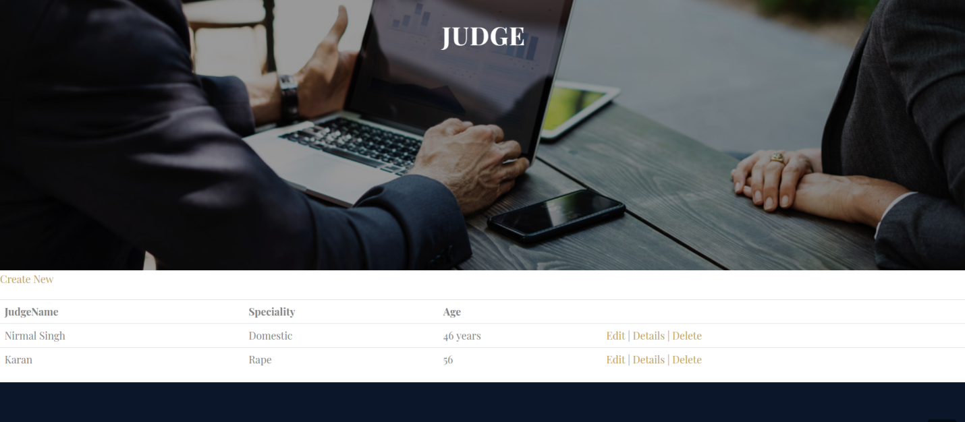

**5. Lawyer: -**  Here I can show the lawyer in my website. And clicking on the create new link I can create the lawyer. Edit and delete customer are also available here.

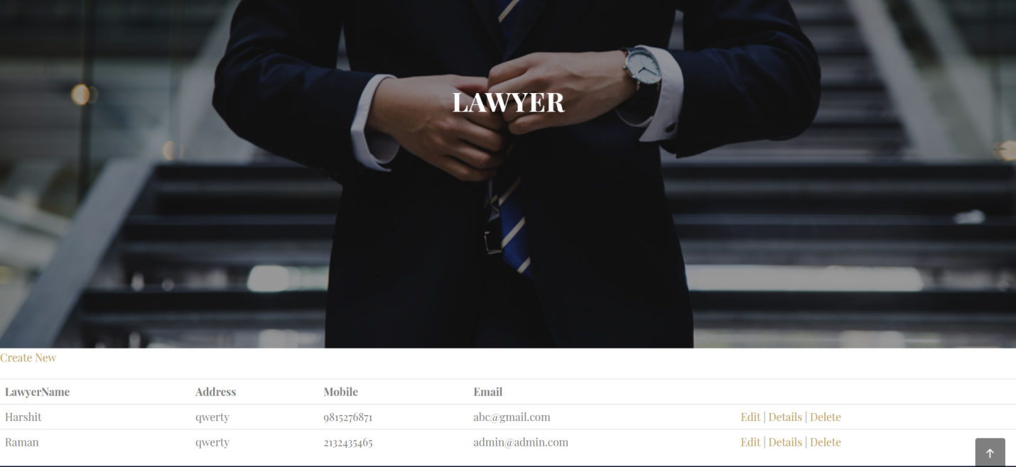

**6. Court Room: -**  Here I can show the court room in my website. And clicking on the create new link I can create the court room. Edit and delete court room are also available here.



**7. Applicant -**  Here I can show the applicant in my website. And clicking on the create new link I can create the applicant. Edit and delete applicant are also available here.

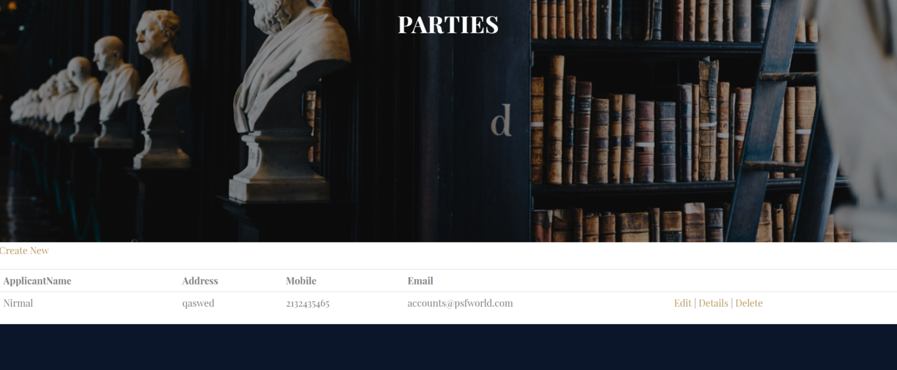

**8. Case File: -**  Here I can show the case file in my website. And clicking on the create new link I can create the case file. Edit and delete case file are also available here.

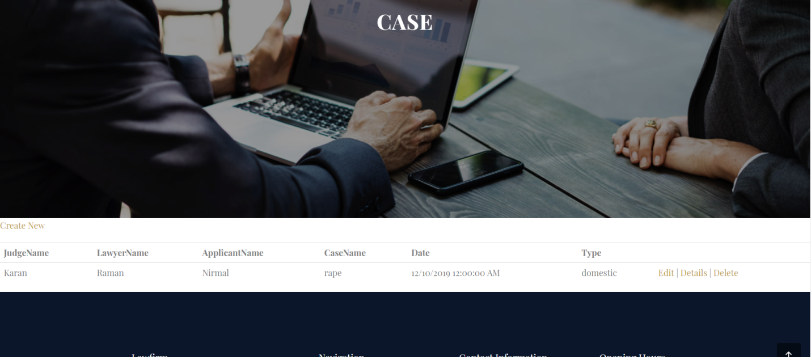

**9. Hearing: -**  Here I can show the hearing in my website. And clicking on the create new link I can create the hearing. Edit and delete hearing are also available here.



**Development:**

After the requirements and design activity is completed, the next phase of the SDLC is the implementation or development of the software. In this phase, developers start coding according to the requirements and the design discussed in previous phases.

Testing:

Testing is the last phase of the software development life cycle before the software is delivered to customers. During testing, experienced testers start to test the system against the requirements.

**Task -9 Project Management:**

Whether you’re in charge of developing a website, designing a car, moving a department to a new facility, updating an information system, or just about any other project (large or small), you’ll go through the same four phases of project management: planning, build-up, implementation, and closeout. Even though the phases have distinct qualities, they overlap.

For example, you’ll typically begin planning with a ballpark budget figure and an estimated completion date. Once you’re in the build-up and implementation phases, you’ll define and begin to execute the details of the project plan. That will give you new information, so you’ll revise your budget and end date—in other words, do more planning—according to your clearer understanding of the big picture.

Planning: How to Map Out a Project

When people think of project planning, their minds tend to jump immediately to scheduling—but you won’t even get to that part until the build-up phase. Planning is really about defining fundamentals: what problem needs solving, who will be involved, and what will be done.

Determine the real problem to solve

Before you begin, take time to pinpoint what issue the project is actually supposed to fix. It’s not always obvious. Say the CIO at your company has asked you, an IT manager, to develop a new database and data entry system. You may be eager to jump right into the project to tackle problems you have struggled with firsthand.